Write a mapreduce code to find out number of males and females survived in the titanic tragedy and save the output in sequence file output format.

Driver:

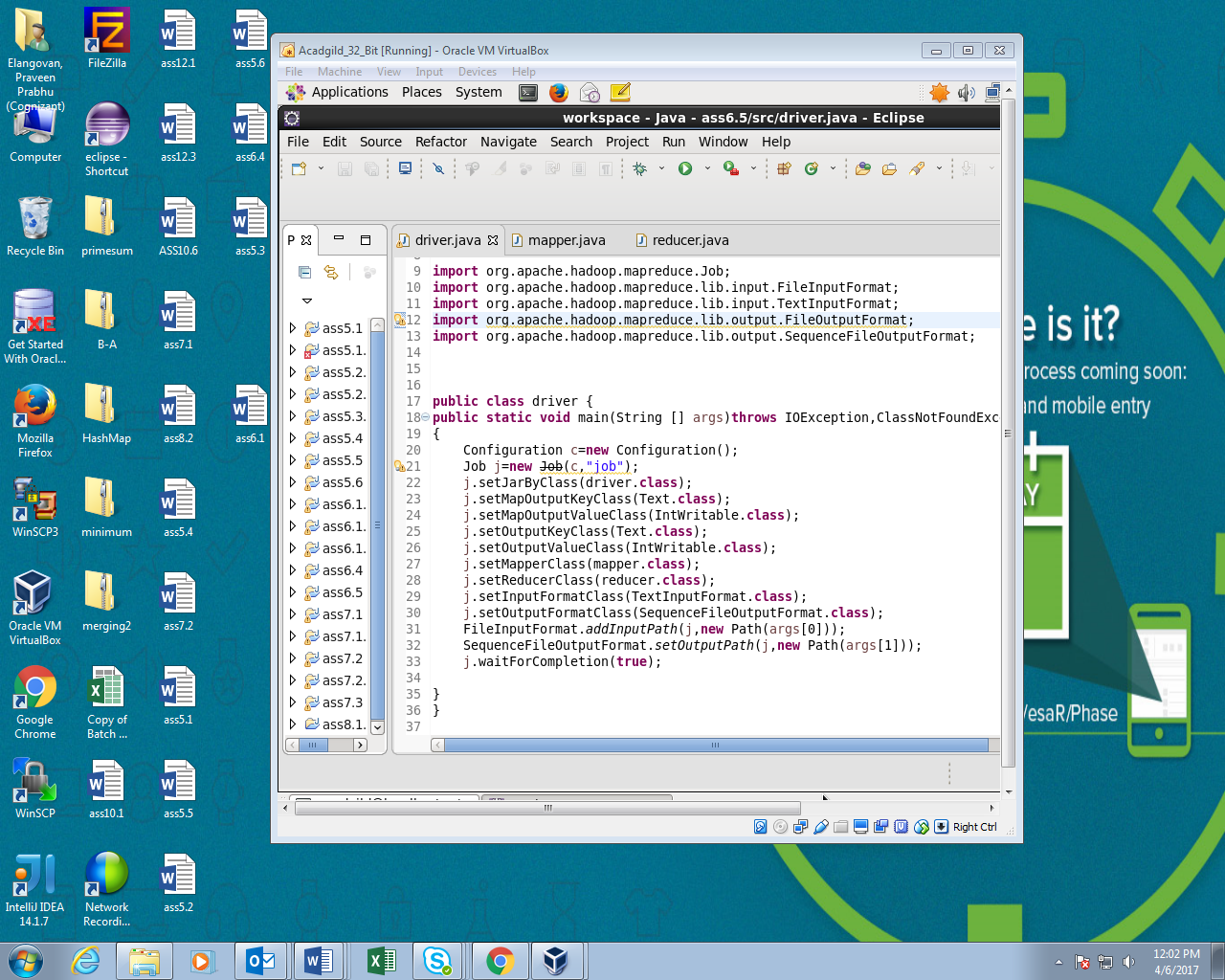

Mapper:

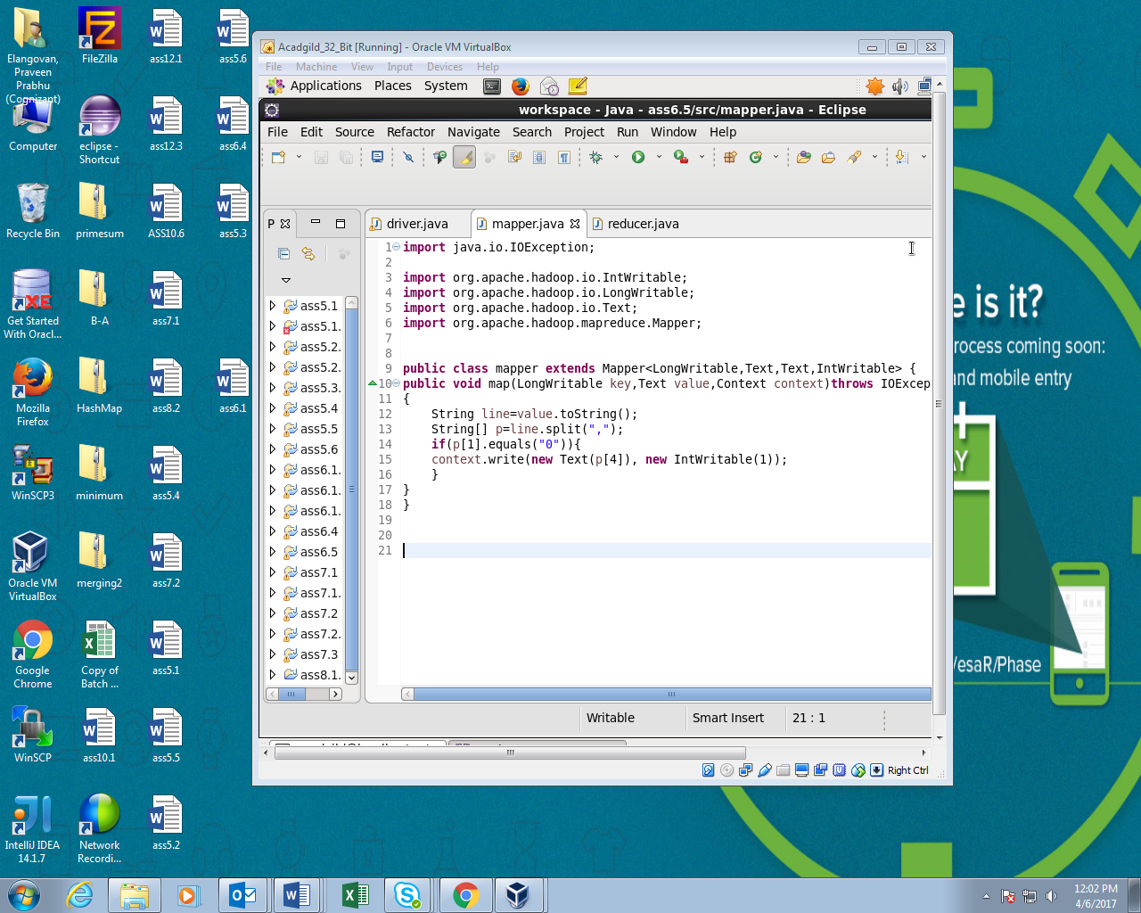

Reducer:

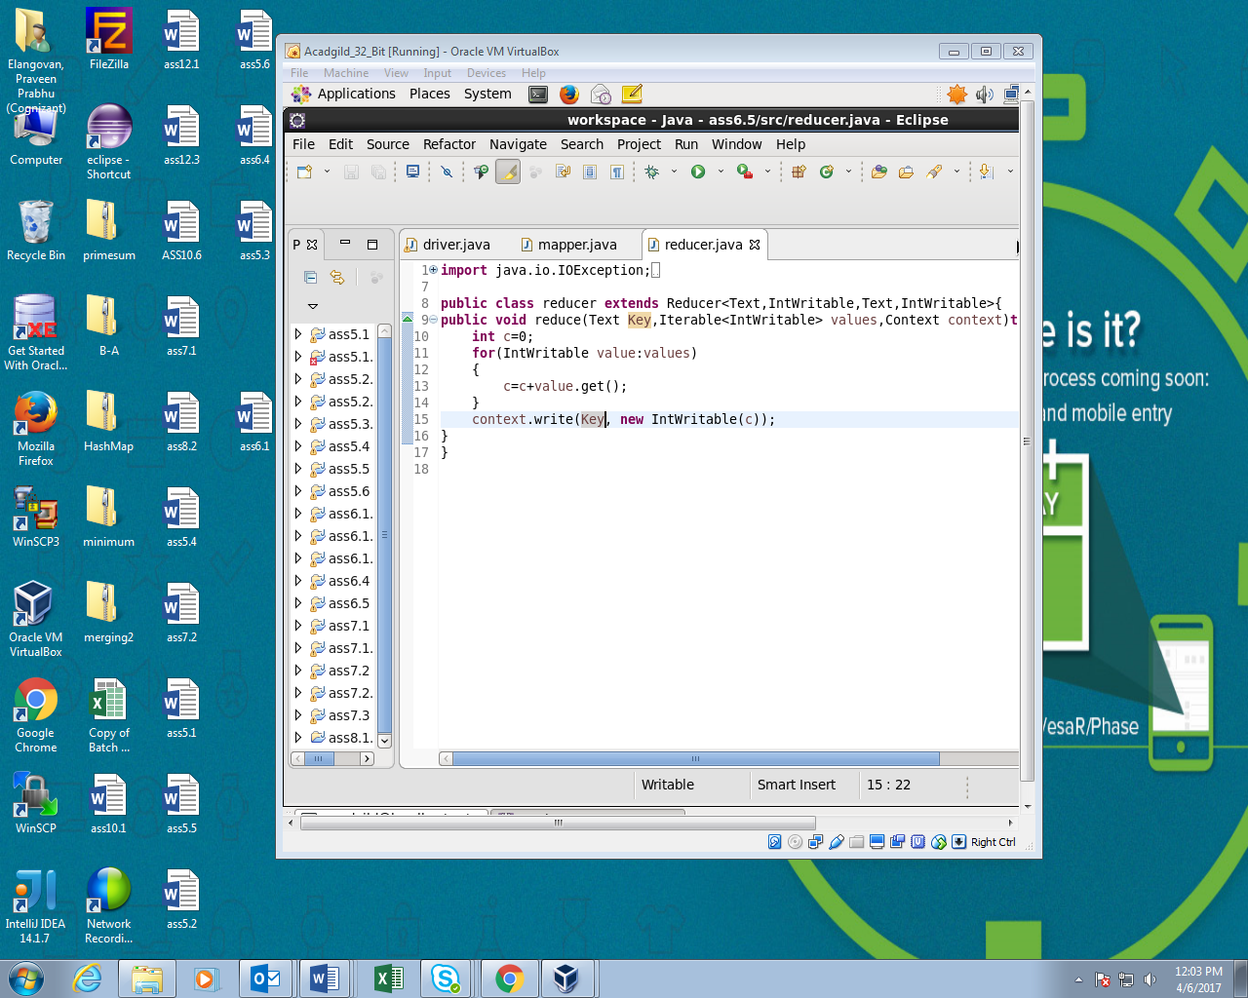

Running JAR file:

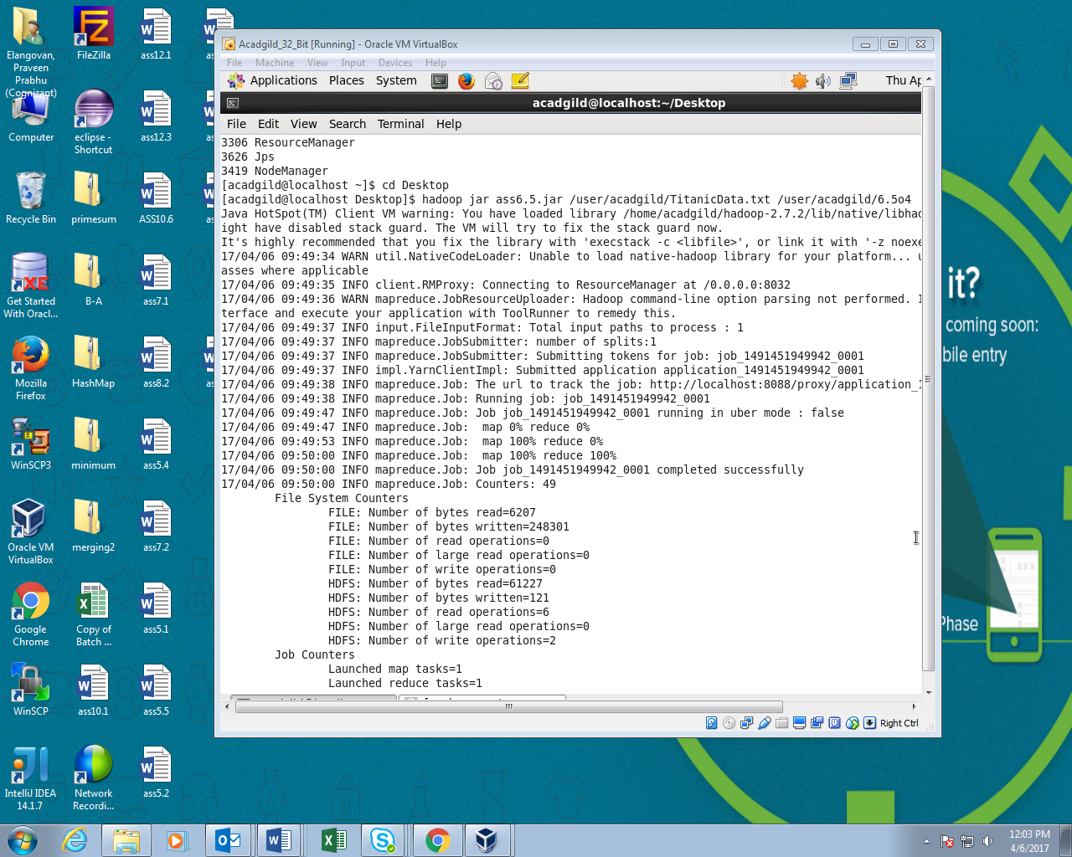

Output:

